Topic 1—Number and algebra (AHL) |  | 20
AHL 1.10  -Counting Principles,  -Combinations and Permutations  -Binomial Theorem for fractional and negative indices | 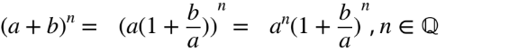  Finding approximations to radical 2 | ✅
AHL 1.11  Rational Equations: Splitting it Partial Fractions | 
AHL 1.12  Intro to Complex numbers, Cartesian form  The complex plane | AKA Argand Diagrams | ✅
AHL 1.13  Modulus–argument (polar) form:  Euler form: | AKA polar coordinates  The ability to convert between Cartesian, modulus- argument (polar) and Euler form is expected. | ✅
AHL 1.14  -Complex conjugate roots of quadratic and  polynomial equations with real coefficients.  -De Moivre’s theorem and its extension to rational exponents.  -Powers and roots of complex numbers. | Complex roots occur in conjugate pairs.  Includes proof by induction for the case where n ∈ Z | ✅
AHL 1.15  Proof by mathematical induction.  Proof by contradiction.  Use of a counterexample to show that a statement is not always true. | Proof should be incorporated throughout the course where appropriate.  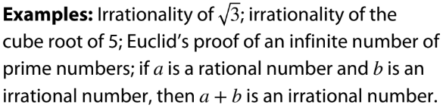  It is not sufficient to state the counterexample alone. Students must explain why their example is a counterexample. | ✅
AHL 1.16  Solutions of systems of linear equations (a  maximum of three equations in three unknowns), including cases where there is a unique solution, an infinite number of solutions or no solution. | Systems which have no solution(s) are inconsistent.  Finding a general solution for a system with an infinite number of solutions.

Topic 2—Functions (AHL) |  | 11
AHL 2.12  Polynomial functions, their graphs and equations; zeros, roots and factors.  The factor and remainder theorems.  Sum and product of the roots of polynomial  equations. | Cover all polynomials, beyond cubic  Synthetic division  The Factor Theorem: If p(x) is a nonzero polynomial, then the real number c is a zero of p(x) if and only if x−c is a factor of p(x) .  The Remainder Theorem: If p(x) is a polynomial of degree 1 or greater and c is a real number, then when p(x) is divided by x−c, the remainder is p(c).  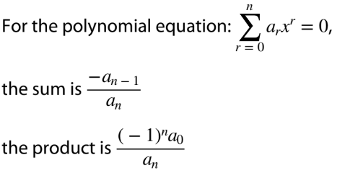 | Chapter 5 HL Text  Do with SL Topic 2  ✅
AHL 2.13  Rational functions of the form  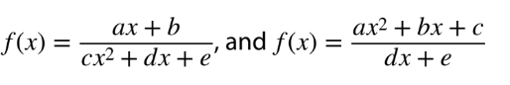 | The reciprocal function is a particular case.  Graphs should include all asymptotes (horizontal, vertical and oblique) and any intercepts with axes.  Dynamic graphing packages could be used to investigate these functions. | HL Core Chapter 15  Chapter 6  ✅
AHL 2.14  -Odd and even functions.  -Finding the inverse function, f −1(x), including domain restriction.  -Self-inverse functions. | Even: f( − x) = f(x)  Odd: f( − x) = − f(x)  Includes periodic functions. | Chapter 6  ✅
AHL 2.15  -Solutions of g(x) ≥ f(x), both graphically and Analytically.  -Quadratic Inequalities  -Cubic Inequalities | Graphical or algebraic methods for simple polynomials up to degree 3. Use of technology for these and other functions. | Core Chapter 4 -Equations
AHL 2.16  The graphs of the functions,  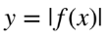 and  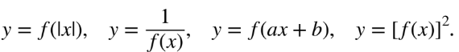 | Dynamic graphing packages could be used to  investigate these transformations. | ✅

Topic 4 —Statistics(AHL) |  | 6
AHL 4.13  Use of Bayes’ theorem for a maximum of three events. | Pair with Combinations, permutations, independent events | Do with SL Topic 4
AHL 4.14  Variance of a discrete random variable.  Continuous random variables and their probability density functions.  Mode and median of continuous random variables.  Mean, variance and standard deviation of both discrete and continuous random variables.  The effect of linear transformations of X. | Pair with 4.7  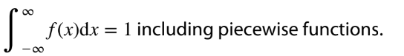  For a continuous random variable, a value at which the probability density function has a maximum  value is called a mode and for the median:  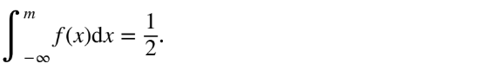  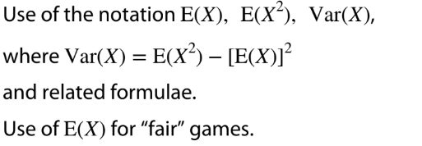  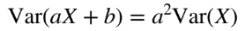

Topic 3 —Geometry & Trigonometry (AHL) |  | 26
AHL 3.9
Definition of the reciprocal trigonometric ratios secθ, cosecθ and cotθ.
Pythagorean identities:

1 + tan2θ = sec2θ
1 + cot2θ = cosec2θ

The inverse functions f(x) = arcsinx,
f(x) = arccosx, f(x) = arctanx; their domains and ranges; their graphs.

AHL 3.10
Compound angle identities.

Double angle identity for tan.

AHL 3.11  Relationships between trigonometric functions and the symmetry properties of their graphs. | 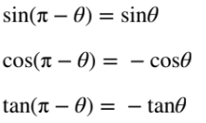  Link to: the unit circle (SL3.5), odd and even functions (AHL2.14), compound angles (AHL3.10).
AHL 3.12  Concept of a vector; position vectors; displacement vectors.  Representation of vectors using directed line segments.  Base vectors i, j, k.  Components of a vector:  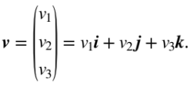  Algebraic and geometric approaches to the  following:  • the sum and difference of two vectors  • the zero vector 0, the vector −v  • multiplication by a scalar, kv, parallel vectors  • magnitude of a vector, |v|; unit vectors, v  |v|  •position vectors OA→= a,  OB→= b  •displacement vector AB→= b − a  Proofs of geometrical properties using vectors. | Distance between points A and B is the magnitude of AB→
AHL 3.13  The definition of the scalar product of two vectors.  The angle between two vectors.  Perpendicular vectors; parallel vectors. | Applications of the properties of the scalar product  v · w = w · v;  u · (v + w) = u · v + u · w;  (kv) · w = k(v · w);  v · v = v^2  v · w = v w cosθ, where θ is the angle between v and w.  For non-zero vectors v · w = 0 is equivalent to the vectors being perpendicular; for parallel vectors  |v ⋅ w| = |v||w|.
AHL 3.14  Vector equation of a line in two and three dimensions:  r = a + λb.  The angle between two lines.  Simple applications to kinematics. | Relevance of a (position) and b (direction).  Knowledge of the following forms for equations of lines:  Parametric form:  Cartesian form:  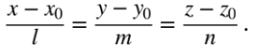
AHL 3.15  Coincident, parallel, intersecting and skew lines, distinguishing between these cases.  Points of intersection. | Skew lines are non-parallel lines that do not intersect in three-dimensional space.
AHL 3.16  The definition of the vector product of two vectors.  Properties of the vector product.  Geometric interpretation of | v × w | | The vector product is also known as the “cross product”.  v × w = v w sinθn, where θ  is the angle between v and w, and n is the unit normal vector whose direction is given by the right-  hand screw rule.  v × w = − w × v;  u × (v + w) = u × v + u × w;  (kv) × w = k(v × w);  v × v = 0.  For non-zero vectors v × w = 0 is equivalent to the  vectors being parallel.  Use of | v × w | to find the area of a parallelogram (and hence a triangle).
AHL 3.17
Vector equations of a plane:
r = a + λb + μc, where b and c are non-parallel vectors within the plane.
r · n = a · n, where n is a normal to the plane and a is the position vector of a point on the plane.

Cartesian equation of a plane ax + by + cz = d.

AHL 3.18  Intersections of: a line with a plane; two planes; three planes.  Angle between: a line and a plane; two planes. | Finding intersections by solving equations; geometrical interpretation of solutions.  Link to: solutions of systems of linear equations (AHL 1.16).

Topic 5 —Calculus (AHL) |  | 27
AHL 5.12  Informal understanding of continuity and  differentiability of a function at a point.  Understanding of limits (convergence and divergence).  Definition of derivative from first principles  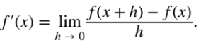  Higher derivatives. | In examinations, students will not be asked to test for continuity and differentiability.  Familiarity with the notations  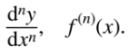  Link to: infinite geometric sequences (SL1.8).  Use of this definition for polynomials only.
TOK: Does the fact that Leibniz and Newton came across the Calculus at similar times support the argument of Platonists over Constructivists?
AHL 5.13  The evaluation of limits of the form 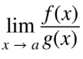 and 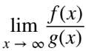 using l’Hôpital’s rule or the Maclaurin series.  Repeated use of l’Hôpital’s rule. | The indeterminate forms 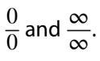  For example: 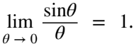  Link to: horizontal asymptotes (SL2.8) .
AHL 5.14  Implicit differentiation.  Related rates of change.  Optimisation problems. | Appropriate use of the chain rule or implicit differentiation, including cases where the optimum solution is at the end point.
TOK: Euler was able to make important advances in mathematical analysis before calculus had been put on a solid theoretical foundation by Cauchy and others. However, some work was not possible until after Cauchy’s work. What does this suggest about the nature of progress and development in mathematics? How might this be similar/different to the nature of progress and development in other areas of knowledge?
AHL 5.15  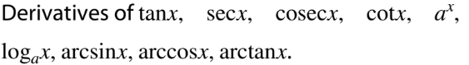  Indefinite integrals of the derivatives of any of the above functions.  The composites of any of these with a linear function.  Use of partial fractions to rearrange the integrand. | Indefinite integral interpreted as a family of curves.  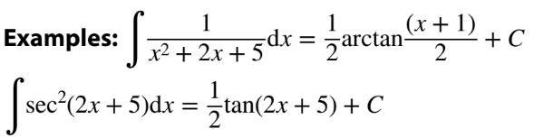  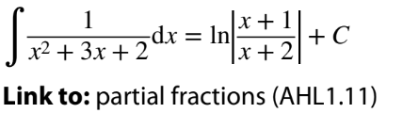
TOK: Can a mathematical statement be true before it has been proven?
AHL 5.16  Integration by substitution.  Integration by parts.  Repeated integration by parts. | On examination papers, substitutions will be provided if the integral is not of the form  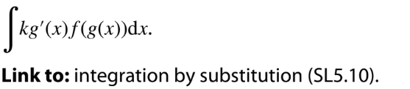    
AHL 5.17
Area of the region enclosed by a curve and the y-axis in a given interval.

Volumes of revolution about the x-axis or y-axis.

AHL 5.18  First order differential equations.  Numerical solution of 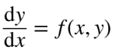 using Euler’s method.  Variables separable.  Homogeneous differential equation 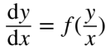using the substitution y = vx.  Solution of y′ + P(x)y = Q(x), using the integrating factor. | xn + 1 = xn + h, where h is a constant.  Example: the logistic equation  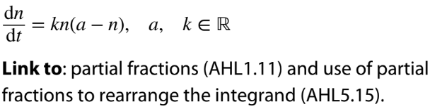
TOK: Does personal experience play a role in the formation of knowledge claims in mathematics? Does it play a different role in mathematics compared to other areas of knowledge?
AHL 5.19  Maclaurin series to obtain expansions for  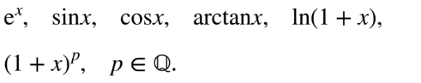  Use of simple substitution, products, integration and differentiation to obtain other series.  Maclaurin series developed from differential  equations. | 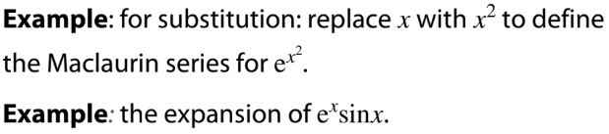
TOK: Is there always a trade-off between accuracy and simplicity?

